**PART 1:**

/*Part 1 */

/*Question 1*/

/*NBD Model for billboard exposures example*/

proc print data=mis6334.billboard;run;

PROC NLMIXED DATA=mis6334.billboard;

retain factor 0;

parms shapeR=0.5 alpha=0.5; /*lambda is gamma distrbuted with parameters shape r and scale alpha;*/

IF exposures = 0 THEN

DO;

factor= (alpha/(alpha + 1))**shapeR; /*for exposures = 0*/

ll = peoplecount*log(factor);

END;

ELSE

DO;

ll = peoplecount * log(factor * ((shapeR + exposures - 1)/(exposures*(alpha + 1))));

factor = (factor * ((shapeR + exposures - 1)/(exposures*(alpha + 1))));

END;

MODEL exposures ~ general(ll);

RUN;

/*Question 2*/

proc print data=mis6334.kc(obs=10);run;

proc nlmixed data=mis6334.kc;

  parms lambda0=1 beta1=0 beta2=0 beta3=0 beta4=0;

  lambda=lambda0*exp(beta1*income+beta2*sex+beta3*age+beta4*HHSize);

  logprob = - lambda + total*log(lambda) - log(fact(total));

  ll = logprob;

  model total ~ general(ll);

run;

/*Question 3*/

proc nlmixed data=mis6334.kc;

  parms shapeR=1 alpha=1 beta1=0 beta2=0 beta3=0 beta4=0;

  expBX=exp(beta1*income+beta2*sex+beta3*age+beta4*HHSize);

  component1 = log(gamma(shapeR+total))-log(gamma(shapeR))-log(fact(total));

  component2 = shapeR*log(alpha/(alpha+expBX));

  component3 = total*log(expBX/(alpha+expBX));

  ll = component1 + component2 + component3;

  model total ~ general(ll);

run;

**Part2**

Answer1

1. **Writing data set in sas:**

libname mis "C:\Users\virendsi\Desktop\ABI project"; **run**;

**proc** **import** datafile="C:\Users\virendsi\Google Drive\Study\3rd sem\ABI\HW\project\books.txt" out=mis.booksnew dbms=dlm replace;

delimiter='09'x;

getnames=yes;

**run**;

/*barnesandnoble.com truncated to barnesandn */

/*but that works since we have two values only*/

**data** mis.booksnew;

set mis.booksnew(drop= var15);**run**;

/* extra column dropped*/

1. Data cleaning:

1 row with amazon.com domain has quantity as 0 so removing the variable.

2. 46 rows with region as * value convert into missing.

**data** miss;

set mis.booksnew;

if region = '*' then region= **.**;

if qty= **.** then delete;

**run**;

1. Find the total number of book purchased by each user.

Sorting:

**proc** **sort** data =miss; by userid;**run**;

**summation:**

**data** books_1(drop = domain date product qty price);

set miss;

by userid;

if first.userid then t_qty=**0**; /*total quantity assigned to zero for the first record of the group*/

if domain = "barnesandn" then t_qty + qty; /*total quantity summed up successively for "barnesandn"*/

if last.userid;

**run**;

first ten observations.

| **Obs** | **userid** | **education** | **region** | **hhsz** | **age** | **income** | **child** | **race** | **country** | **t_qty** |
| --- | --- | --- | --- | --- | --- | --- | --- | --- | --- | --- |
| **1** | 6365661 | 5 | 1 | 2 | 11 | 7 | 0 | 1 | 0 | 0 |
| **2** | 6388054 | 2 | 4 | 1 | 6 | 5 | 0 | 1 | 0 | 0 |
| **3** | 6628110 | 4 | 4 | 5 | 4 | 7 | 1 | 1 | 0 | 0 |
| **4** | 6631403 | 5 | 3 | 1 | 10 | 3 | 0 | 1 | 1 | 0 |
| **5** | 6704851 | 5 | 4 | 1 | 6 | 7 | 0 | 1 | 0 | 0 |
| **6** | 7412556 | 5 | 4 | 3 | 10 | 7 | 0 | 1 | 1 | 0 |
| **7** | 8985187 | 2 | 4 | 3 | 11 | 5 | 1 | 1 | 0 | 0 |
| **8** | 9350810 | 4 | 3 | 2 | 6 | 7 | 0 | 1 | 0 | 0 |
| **9** | 9363405 | 2 | 3 | 3 | 2 | 5 | 0 | 2 | 0 | 0 |
| **10** | 9552099 | 5 | 2 | 2 | 5 | 7 | 0 | 1 | 0 | 0 |

Answer 2:

As the t_qty was not sequential in & probability is missing for many t_qty>20 we are taking data where t_qty<=20;

NBD model:

**PROC** **NLMIXED** DATA=mis.books_2;

retain factor **0**;

parms shapeR=**0.5** alpha=**0.5**; /*lambda is gamma distrbuted with parameters shape r and scale alpha;*/

IF t_qty = **0** THEN /*for quantity=0*/

DO;

factor=((alpha/(alpha + **1**)) ** shapeR);

ll=peoplecount*log(factor);

END;

ELSE

DO; /*For Quantity > 0 */

ll = peoplecount * log(factor * ((shapeR + t_qty - **1**)/(t_qty*(alpha + **1**))));

factor = (factor * ((shapeR + t_qty - **1**)/(t_qty*(alpha + **1**))));

END;

MODEL t_qty ~ general(ll);

**RUN**;

| **Fit Statistics** | |
| --- | --- |
| **-2 Log Likelihood** | 12694 |
| **AIC (smaller is better)** | 12698 |
| **AICC (smaller is better)** | 12699 |
| **BIC (smaller is better)** | 12700 |

| **Parameter Estimates** | | | | | | | | |
| --- | --- | --- | --- | --- | --- | --- | --- | --- |
| **Parameter** | **Estimate** | **Standard Error** | **DF** | **t Value** | **Pr > |t|** | **95% Confidence Limits** | | **Gradient** |
| **shaper** | 0.1119 | 0.004276 | 21 | 26.17 | <.0001 | 0.1030 | 0.1208 | -0.00009 |
| **Alpha** | 0.2197 | 0.01164 | 21 | 18.88 | <.0001 | 0.1955 | 0.2439 | 0.003054 |

R =.1119

Alpha = .2197

Answer 3:

Effectiveness measures:

Reach: 100*(1-

Answer 4

Original variables converted in dummy variables

**data** books_3;

set books_1;

if region =**.** then delete;

/* creating dummy variable for region*/

if region = **2** then reg2 =**1**;else reg2 =**0**;

if region = **3** then reg3 =**1**;else reg3 =**0**;

if region = **4** then reg4 =**1**;else reg4 =**0**;

/*Created dummy variables for education categorical variable*/

if education = **0** then e0 = **1**; else e0 = **0**;

if education = **1** then e1 = **1**; else e1 = **0**;

if education = **2** then e2 = **1**; else e2 = **0**;

if education = **3** then e3 = **1**; else e3 = **0**;

if education = **4** then e4 = **1**; else e4 = **0**;

if education = **5** then e5 = **1**; else e5 = **0**;

/*Created dummy variables for income categorical variable*/

/*if income = 1 then i1 = 1;

else i1 = 0;*/

if income = **2** then i2 = **1**; else i2 = **0**;

if income = **3** then i3 = **1**; else i3 = **0**;

if income = **4** then i4 = **1**; else i4 = **0**;

if income = **5** then i5 = **1**; else i5 = **0**;

if income = **6** then i6 = **1**; else i6 = **0**;

/*Created dummy variables for age categorical variable*/

/*if age = 1 then a1 = 1;

else a1 = 0;*/

if age = **2** then a2 = **1**; else a2 = **0**;

if age = **3** then a3 = **1**; else a3 = **0**;

if age = **4** then a4 = **1**; else a4 = **0**;

if age = **5** then a5 = **1**; else a5 = **0**;

if age = **6** then a6 = **1**; else a6 = **0**;

if age = **7** then a7 = **1**; else a7 = **0**;

if age = **8** then a8 = **1**; else a8 = **0**;

if age = **9** then a9 = **1**; else a9 = **0**;

if age = **10** then a10 = **1**; else a10 = **0**;

if age = **11** then a11 = **1**; else a11 = **0**;

/*if race = 11 then r1 = 1;

else r = 0;*/

if race = **2** then r2 = **1**; else r2 = **0**;

if race = **3** then r3 = **1**; else r3 = **0**;

if race = **4** then r4 = **1**; else r4 = **0**;

**run**;

Poisson regression sas code:

**proc** **nlmixed** data=books_3;

parms lambda0=**1** b0=**0** b1=**0** b2=**0** b3=**0** b4=**0** b5=**0** b6=**0** b7=**0** b8=**0** b9=**0** b10=**0** b11=**0** b12=**0** b13=**0** b14=**0**

b15=**0** b16=**0** b17=**0** b18=**0** b19=**0** b20=**0** b21=**0** b22=**0.5** b23=**0** b24=**0** b25=**0** b26 = **0** b27 =**0** b28 = **0** b29 =**0** b30 =**0** ;

lambda=lambda0*exp(b0+b1*hhsz + b2*child + b3*country + b4*e0 + b5*e1 + b6*e2 + b7*e3 + b8*e4 +

b9*e5 + b10*a2 + b11*a3 + b12*a4 + b13*a5 + b14*a6 + b15*a7 + b16*a8 + b17*a9 + b18*a10 + b19*a11

+ b20*r2 + b21*r3 + b22*r4+b23*reg2+b24*reg3+b25*reg4 +b26*i2+b27*i3+b28*i4+b29*i5+b30*i6);

logprob = - lambda + t_qty*log(lambda) - log(fact(t_qty));

ll = logprob;

model t_qty ~ general(ll);

**run**;

results

| **Fit Statistics** | |
| --- | --- |
| **-2 Log Likelihood** | 29686 |
| **AIC (smaller is better)** | 29750 |
| **AICC (smaller is better)** | 29751 |
| **BIC (smaller is better)** | 29974 |

| **Parameter Estimates** | | | | | | | | |
| --- | --- | --- | --- | --- | --- | --- | --- | --- |
| **Parameter** | **Estimate** | **Standard Error** | **DF** | **t Value** | **Pr > |t|** | **95% Confidence Limits** | | **Gradient** |
| **lambda0** | 0.6466 | . | 8134 | . | . | . | . | 0.30706 |
| **b0** | -0.3711 | . | 8134 | . | . | . | . | 0.19853 |
| **b1** | -0.00285 | 0.01261 | 8134 | -0.23 | 0.8209 | -0.02756 | 0.02186 | 0.56605 |
| **b2** | 0.09791 | 0.03694 | 8134 | 2.65 | 0.0081 | 0.02549 | 0.1703 | -0.25687 |
| **b3** | -0.06178 | 0.03809 | 8134 | -1.62 | 0.1048 | -0.1364 | 0.01288 | -0.05235 |
| **b4** | -0.3866 | 1.6542 | 8134 | -0.23 | 0.8152 | -3.6292 | 2.8559 | 0.36611 |
| **b5** | 0.2631 | 0.05026 | 8134 | 5.24 | <.0001 | 0.1646 | 0.3616 | -0.19155 |
| **b6** | 0.3373 | 0.04486 | 8134 | 7.52 | <.0001 | 0.2494 | 0.4252 | 0.22134 |
| **b7** | -0.1609 | 0.3983 | 8134 | -0.40 | 0.6862 | -0.9417 | 0.6198 | -0.66808 |
| **b8** | -0.2972 | 0.05649 | 8134 | -5.26 | <.0001 | -0.4079 | -0.1865 | -0.03284 |
| **b9** | -0.2079 | 0.08943 | 8134 | -2.32 | 0.0201 | -0.3832 | -0.03261 | -0.14873 |
| **b10** | 0.04004 | 0.3042 | 8134 | 0.13 | 0.8953 | -0.5563 | 0.6364 | -0.41773 |
| **b11** | 0.4944 | 0.2855 | 8134 | 1.73 | 0.0833 | -0.06520 | 1.0540 | 0.16789 |
| **b12** | 0.4455 | 0.2827 | 8134 | 1.58 | 0.1151 | -0.1087 | 0.9997 | 0.12064 |
| **b13** | 0.3743 | 0.2822 | 8134 | 1.33 | 0.1847 | -0.1789 | 0.9275 | -0.09073 |
| **b14** | 0.7606 | 0.2806 | 8134 | 2.71 | 0.0067 | 0.2105 | 1.3107 | 0.036910 |
| **b15** | 0.3432 | 0.2815 | 8134 | 1.22 | 0.2227 | -0.2085 | 0.8950 | -0.11035 |
| **b16** | 0.5098 | 0.2812 | 8134 | 1.81 | 0.0698 | -0.04134 | 1.0610 | 0.14248 |
| **b17** | 0.6989 | 0.2815 | 8134 | 2.48 | 0.0131 | 0.1470 | 1.2507 | 0.41377 |
| **b18** | 0.2592 | 0.2846 | 8134 | 0.91 | 0.3624 | -0.2986 | 0.8171 | 0.54794 |
| **b19** | 0.6492 | 0.2816 | 8134 | 2.31 | 0.0212 | 0.09718 | 1.2012 | -0.49429 |
| **b20** | -0.5857 | 0.1108 | 8134 | -5.29 | <.0001 | -0.8028 | -0.3686 | 0.29042 |
| **b21** | -0.2706 | 0.1269 | 8134 | -2.13 | 0.0330 | -0.5194 | -0.02178 | 0.25760 |
| **b22** | 0.5000 | 0 | 8134 | Infty | <.0001 | -Infty | Infty | 0 |
| **b23** | -0.1814 | 0.03863 | 8134 | -4.69 | <.0001 | -0.2571 | -0.1056 | -0.09742 |
| **b24** | -0.3236 | 0.03563 | 8134 | -9.08 | <.0001 | -0.3935 | -0.2538 | -0.10095 |
| **b25** | -0.3440 | 0.04009 | 8134 | -8.58 | <.0001 | -0.4225 | -0.2654 | -0.17565 |
| **b26** | -0.07363 | 0.06164 | 8134 | -1.19 | 0.2323 | -0.1945 | 0.04721 | 0.11980 |
| **b27** | -0.2260 | 0.05790 | 8134 | -3.90 | <.0001 | -0.3395 | -0.1125 | 0.019061 |
| **b28** | 0.02839 | 0.04541 | 8134 | 0.63 | 0.5320 | -0.06064 | 0.1174 | 0.013860 |
| **b29** | 0.1496 | 0.03649 | 8134 | 4.10 | <.0001 | 0.07811 | 0.2212 | 0.025943 |
| **b30** | 0.1496 | 0.03997 | 8134 | 3.74 | 0.0002 | 0.07121 | 0.2279 | 0.040580 |

important variables are:

child when child =1 has positive effect compared to child =0,

education when education = 1 has positive effect compared to education =99 ( we have taken reference as education = 99)

education when education =2 has a positive effect compared to education =99

education when education = 4 has a negative effect compared to education =99

education when education = 5 has a negative effect compared to education =99

age when age =6 , 8 ,9,11 all have positive effects compared to age 1

race when race =2,3 ( both have negative effect on purchase),4 (positive effect) compare to race 1

region 1 has positive effect compared to region (2,3,4)

when income is = 3 has a negative effect compared to income =1

when income =5,6 has positive effect compared to income =1

**recommendation:**

**Based on above result targeting customers with child, age ( value=6,8,9,11), education(value =1,2,) race (value =4) with income(values=5,6) will result into more sell compared to baseline variable shown above.**

With the help of below code we estimate lambda value for each customer and predict likelihood compared to others

%let lambda0= 0.6466;%let b0 = -0.3711;%let b1 = -0.00285;

%let b2=0.09791;

%let b3 = -0.06178;

%let b4 = -0.3866;

%let b5 = 0.2631;

%let b6 = 0.3373;

%let b7 = -0.1609;

%let b8 = -0.2972;

%let b9 = -0.2079;

%let b10 = 0.04004;

%let b11 = 0.4944;

%let b12 = 0.4455;

%let b13 = 0.3743;

%let b14 = 0.7606;

%let b15 = 0.3432;

%let b16 = 0.5098;

%let b17 = 0.6989;

%let b18 = 0.2592;

%let b19 = 0.6492;

%let b20 = -0.5857;

%let b21 = -0.2706;

%let b22 = 0.5;

%let b23 = -0.1814;

%let b24 = -0.3236;

%let b25 = -0.344;

%let b26 = -0.07363;

%let b27 = -0.226;

%let b28 =0.02839;

%let b29 =0.1496;

%let b30 = 0.1496;

**data** BNProb;

set books_3;

lambda=&lambda0*exp(&b0+&b1*hhsz + &b2*child + &b3*country + &b4*e0 + &b5*e1 + &b6*e2 + &b7*e3 + &b8*e4 +

&b9*e5 + &b10*a2 + &b11*a3 + &b12*a4 + &b13*a5 + &b14*a6 + &b15*a7 + &b16*a8 + &b17*a9 + &b18*a10 + &b19*a11

+ &b20*r2 + &b21*r3 + &b22*r4+&b23*reg2+&b24*reg3+&b25*reg4 +&b26*i2+&b27*i3+&b28*i4+&b29*i5+&b30*i6);

array prob (**11**) prob0 - prob10; /* prob(y+1)=proby */

prob0=poisson(lambda,**0**);

prob10=**1**-prob0; /* prob of visited 10+ times. */

do y=**1** to **9**;

prob(y+**1**)=poisson(lambda,y)-poisson(lambda,y-**1**);

prob10=prob10-prob(y+**1**);

end;

**run**;

above code gives probability of buying books with probability 0 to 10 based on customer characterstics

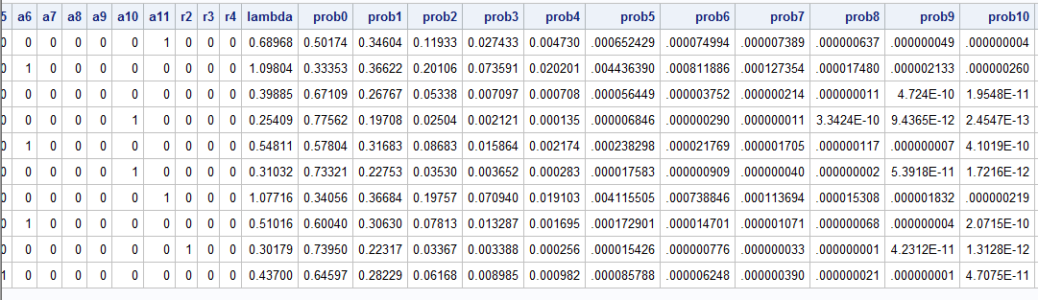

Difference between actual vs predicted

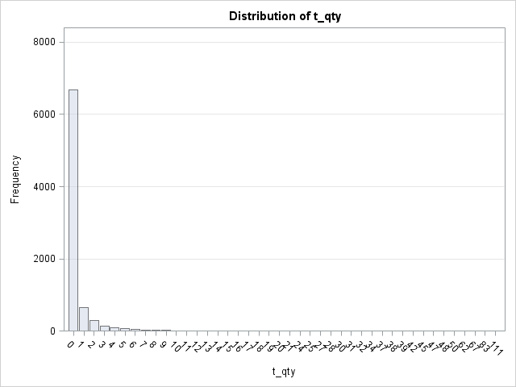 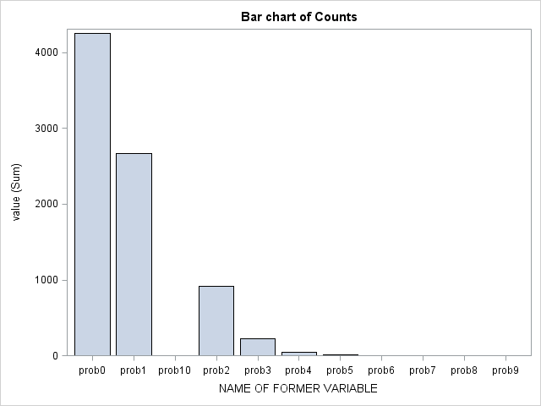

Actual Predicted

The model fit is not good as you can see from the actual and predicted values.

Reason: Result has not captured observed heterogeneity. To solve this problem we will implement NBD regression.

Answer 5:

Formula for log likelihood:

LL = nlog(gamma(nbdr+t_qty))-log(gamma(nbdr))-log(fact(t_qty))+nbdr*log(alpha/(alpha+expo))+t_qty*log(expo/(alpha+expo));

Answer 6 :

NBD Regression SAS Code:

**proc** **nlmixed** data=books_3;

parms nbdr=**1** alpha=**1** b0=**0** b1=**0** b2=**0** b3=**0** b4=**0** b5=**0** b6=**0** b7=**0** b8=**0** b9=**0** b10=**0** b11=**0** b12=**0** b13=**0**

b14=**0** b15=**0** b16=**0** b17=**0** b18=**0** b19=**0** b20=**0** b21=**0** b22=**0.5** b23=**0** b24=**0** b25=**0** b26 = **0** b27 =**0** b28 = **0** b29 =**0** b30 =**0**;

expo =exp(b0+b1*hhsz + b2*child + b3*country + b4*e0 + b5*e1 + b6*e2 + b7*e3 + b8*e4 + b9*e5+ b10*a2 +

b11*a3 + b12*a4 + b13*a5 + b14*a6 + b15*a7 + b16*a8 + b17*a9 + b18*a10 + b19*a11 + b20*r2 + b21*r3

+ b22*r4+b23*reg2+b24*reg3+b25*reg4+b26*i2+b27*i3+b28*i4+b29*i5+b30*i6);

logprob = log(gamma(nbdr+t_qty))-log(gamma(nbdr))-log(fact(t_qty))+nbdr*log(alpha/(alpha+expo))+t_qty*log(expo/(alpha+expo));

ll =logprob;

model t_qty ~ general(ll);

**run**;

| **Fit Statistics** | |
| --- | --- |
| **-2 Log Likelihood** | 13414 |
| **AIC (smaller is better)** | 13480 |
| **AICC (smaller is better)** | 13480 |
| **BIC (smaller is better)** | 13711 |

| **Parameter Estimates** | | | | | | | | |
| --- | --- | --- | --- | --- | --- | --- | --- | --- |
| **Parameter** | **Estimate** | **Standard Error** | **DF** | **t Value** | **Pr > |t|** | **95% Confidence Limits** | | **Gradient** |
| **nbdr** | 0.09484 | 0.003373 | 8134 | 28.12 | <.0001 | 0.08823 | 0.1014 | -4.80802 |
| **alpha** | 0.3686 | . | 8134 | . | . | . | . | 0.32912 |
| **b0** | 0.7185 | . | 8134 | . | . | . | . | -0.12132 |
| **b1** | 0.003782 | 0.03770 | 8134 | 0.10 | 0.9201 | -0.07012 | 0.07768 | -0.39887 |
| **b2** | 0.09451 | 0.1038 | 8134 | 0.91 | 0.3625 | -0.1089 | 0.2979 | -0.24891 |
| **b3** | -0.02508 | 0.1090 | 8134 | -0.23 | 0.8180 | -0.2387 | 0.1886 | -0.05411 |
| **b4** | -0.2191 | 8.4608 | 8134 | -0.03 | 0.9793 | -16.8044 | 16.3662 | 0.077791 |
| **b5** | 0.1799 | 0.1603 | 8134 | 1.12 | 0.2616 | -0.1343 | 0.4942 | 0.12889 |
| **b6** | 0.2858 | 0.1466 | 8134 | 1.95 | 0.0513 | -0.00160 | 0.5732 | -0.33457 |
| **b7** | -0.5376 | 0.9331 | 8134 | -0.58 | 0.5645 | -2.3668 | 1.2915 | -0.22295 |
| **b8** | -0.3686 | 0.1467 | 8134 | -2.51 | 0.0120 | -0.6562 | -0.08094 | 0.003520 |
| **b9** | -0.1937 | 0.2300 | 8134 | -0.84 | 0.3996 | -0.6446 | 0.2571 | 0.17411 |
| **b10** | -0.1435 | 0.7173 | 8134 | -0.20 | 0.8414 | -1.5496 | 1.2626 | -0.21909 |
| **b11** | 0.3535 | 0.6809 | 8134 | 0.52 | 0.6036 | -0.9812 | 1.6883 | -0.14258 |
| **b12** | 0.3267 | 0.6712 | 8134 | 0.49 | 0.6265 | -0.9891 | 1.6424 | -0.03223 |
| **b13** | 0.2040 | 0.6685 | 8134 | 0.31 | 0.7603 | -1.1064 | 1.5144 | -0.03473 |
| **b14** | 0.5837 | 0.6657 | 8134 | 0.88 | 0.3806 | -0.7213 | 1.8886 | 0.004862 |
| **b15** | 0.2349 | 0.6661 | 8134 | 0.35 | 0.7244 | -1.0709 | 1.5406 | 0.073974 |
| **b16** | 0.3604 | 0.6666 | 8134 | 0.54 | 0.5888 | -0.9463 | 1.6671 | -0.01338 |
| **b17** | 0.6027 | 0.6698 | 8134 | 0.90 | 0.3682 | -0.7102 | 1.9156 | -0.08909 |
| **b18** | 0.1134 | 0.6744 | 8134 | 0.17 | 0.8665 | -1.2086 | 1.4353 | -0.00217 |
| **b19** | 0.5262 | 0.6693 | 8134 | 0.79 | 0.4318 | -0.7858 | 1.8381 | -0.13302 |
| **b20** | -0.6416 | 0.2521 | 8134 | -2.54 | 0.0110 | -1.1357 | -0.1474 | 0.048553 |
| **b21** | -0.4138 | 0.3292 | 8134 | -1.26 | 0.2087 | -1.0591 | 0.2314 | 0.053136 |
| **b22** | 0.5000 | 0 | 8134 | Infty | <.0001 | -Infty | Infty | 0 |
| **b23** | -0.2540 | 0.1180 | 8134 | -2.15 | 0.0314 | -0.4852 | -0.02273 | -0.09482 |
| **b24** | -0.3979 | 0.1071 | 8134 | -3.72 | 0.0002 | -0.6078 | -0.1880 | -0.07321 |
| **b25** | -0.3527 | 0.1178 | 8134 | -2.99 | 0.0028 | -0.5837 | -0.1217 | -0.07910 |
| **b26** | -0.04520 | 0.1715 | 8134 | -0.26 | 0.7922 | -0.3814 | 0.2910 | -0.13426 |
| **b27** | -0.1954 | 0.1513 | 8134 | -1.29 | 0.1965 | -0.4920 | 0.1011 | -0.17564 |
| **b28** | 0.05010 | 0.1298 | 8134 | 0.39 | 0.6995 | -0.2043 | 0.3045 | -0.01683 |
| **b29** | 0.1395 | 0.1083 | 8134 | 1.29 | 0.1979 | -0.07286 | 0.3518 | 0.029337 |
| **b30** | 0.1580 | 0.1206 | 8134 | 1.31 | 0.1904 | -0.07851 | 0.3945 | 0.023666 |

Important characteristics

Education when education = 2 has a positive effect compared to education =99

Education = 4 has a negative effect compared to education =99

Race = 2 has a negative effect on purchase compared to race =1

Race 4 has a positive effect of .5 compared to race 1

Region 1 has a positive effect on purchase compared to region 2,3,4 with a significant estimate

Recommendation:

Customer with education(value =2), race (value =4), Region (value =1) results has more probability to buy compared to base line variable suggested above.

Result comparison

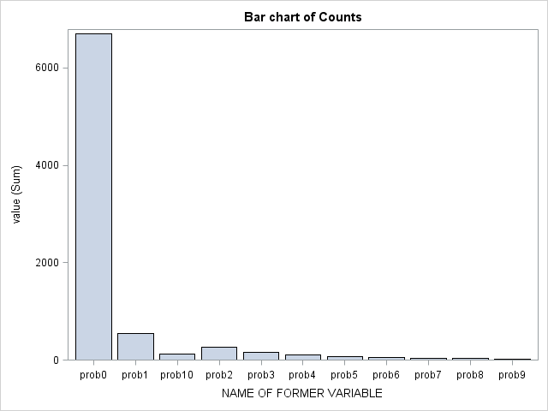

Actual value Predicted value

Similar to previous answer we can predict probabilities to buy number of books based on customer characterstics.

Below table display probability of not buying compared to actual result which is accurate.

| **Obs** | **t_qty** | **prob0** |
| --- | --- | --- |
| **1** | 0 | 0.81346 |
| **2** | 0 | 0.79150 |
| **3** | 0 | 0.85523 |
| **4** | 0 | 0.88157 |
| **5** | 0 | 0.83378 |
| **6** | 0 | 0.86597 |
| **7** | 0 | 0.78844 |
| **8** | 0 | 0.84825 |
| **9** | 0 | 0.88471 |
| **10** | 0 | 0.85228 |

Answer 7

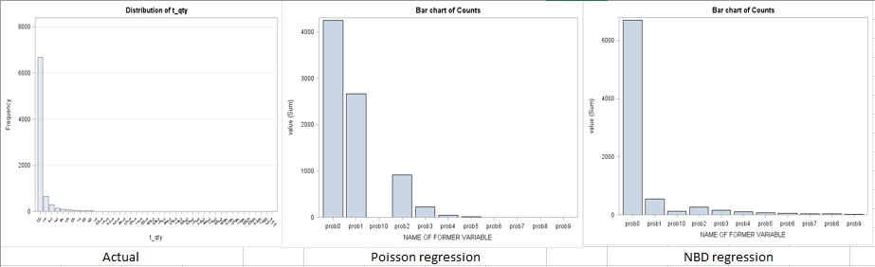

There is a significant difference between Poisson regression and NBD regression as the NBD regression shows more accurate results compared to Poisson regression.

Significance of Parameters has changed in NBD regression compared to Poisson regression as the observed heterogeneity has been considered at individual level.

Answer 8